SNAP Changes to Excess Shelter Costs and Standard Utility Allowances
In July 2025, the President signed H.R.1 into law, which made changes to how the Standard Utility Allowance (SUA) is applied to determine SNAP benefits. This guide summarizes these changes to assist eligibility workers to apply the SUA to participants.
These changes are effective immediately (as of July 4, 2025) and should be applied to all new applications and at recertification for current participants at the latest.

1. Internet expenses are no longer a countable cost
Internet costs are no longer counted as a utility and thus should no longer be included when calculating the excess shelter expense deduction.

2. Fewer people can use LIHEAP to qualify for the Heating and Cooling SUA (HCSUA)
Only households with elderly or disabled members can use the Low Income Home Energy Assistance Program (LIHEAP) or another similar energy assistance payment (as long as the payment is more than $20 in one year) to qualify for the HCSUA. Households without elderly or disabled members must show proof of utility expenses to receive the HCSUA.

HCSUA Screening Flow Chart
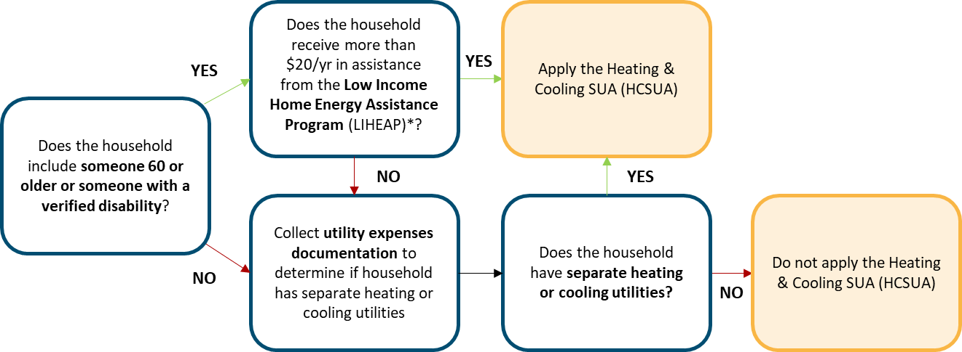
* Another similar energy assistance payment can count as well.
Notes:
- If any part of a household’s electricity bill is used for air conditioning, that can count as a separate heating or cooling utility to qualify for the HCSUA.
- Households that do not qualify for the HCSUA may still be eligible for [states to customize the list of other SUAs a household can qualify for].
- A household is not automatically ineligible to receive a HCSUA if the household does not have an elderly or disabled member; these households can still qualify for the HCSUA if they have heating or cooling expenses.
- The flow chart above applies if a household splits up into multiple households; only the presence of an elderly or disabled member receiving more than $20 in one year from LIHEAP or another energy assistance payment automatically qualifies that household for a HCSUA.
Accepted forms of verification
You can use any of the following ways to verify separate heating or cooling utilities:
- States to customize list - e.g., [insert here].
- Copy of utility bills
- Screenshots of accounts

